## **Maharasi P**

## **Address:** 3/35, Muthuramalingam street, Melapathaneri, Tirunelveli

## **Email:** maharasip4912a@gmail.com

## **Phone:** +91 82487 81809

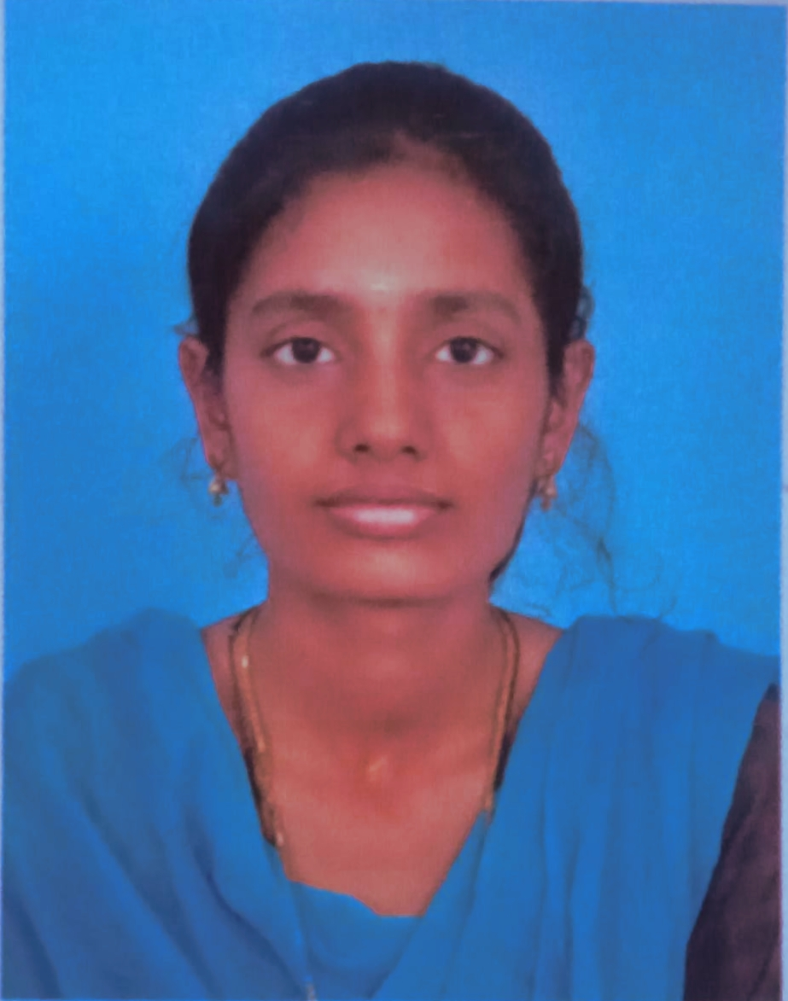

**Education:**

* **School:**
  + Sarah Tucker Higher Secondary School, Tirunelveli.
    - 10th (SSLC) 2020 - 60%
    - 12th (HSC) 2022 - 62%
* **College**
  + Thamirabharani Engineering College, Tirunelveli.
    - B.E. ECE (2022 – Present ) - 7.8 (as of Semester 6)

**Internship:**

* ***Power Integrated Solutions, Trichy – 2025***
* Completed training in Embedded Systems and IoT
* Gained hands-on experience in Arduino programming and coding
* Worked with both hardware and software simulations
* **Hash 8, Tirunelveli – Present**
  + Learned Web development, and gained experience on how to build websites
  + Learned to work with Typescript

**Certificate:**

* **Paper Presentation:**
  1. Infant Jesus college of engineering, Tuticorin
  2. Scad college of engineering, Cheran mahadevi, Tirunelveli
* **Certificates:**

1. Redhat linux
2. **Japanese Endowed Course**, CHG IT Consultancy Pvt. Ltd.

**Technical Skills:** **Programming Skills:**

* Python
* C++
* C program
* Typescript
* Html
* Matlab
* Keil µVision 4 & 5
* Anaconda Navigator
* Dev C++
* VS Code
* Gitlab

**Mini Project:**

* Vehicle number plate Detection
  + Created a program that would detect the vehicle number plate

**Interests:**

* Sports
* Dance
* Reading Books
* Philanthropy